**Galway Mayo Institute of Technology**

**GMIT Mobile Application**

**Aoife Moran**

**G00285256**

**Introduction:**

GMIT Mobile is a mobile web application, designed to give GMIT students easy access to through their mobile phones to any information regarding student life in Galway.

It gives students easy access to information such as student services information, and links to contact lecturers. It contains links for the student library and learn online. It also contains polls for students to vote on different aspects of college life and google maps for easy finding of directions to locations around the city.

Mobile web apps are compatible with iPhone and Android smartphones, and is not required to be downloaded from the App Store or Google’s Android marketplace which makes it a convenient choice for students.

**Aims:**

The main aim of this project is to create a simple to use mobile website that is easy for any student to access, and fulfils the needs of college students.

This mobile app was developed to give students another way to connect with the college through their mobile devices.

**Installing the Application Services**

To install the application services, I went to the start menu and chose run to launch the aspnet_regsql.exe tool. I then entered %WINDIR%\Microsoft.Net\Framework\v2.0.50727\aspnet_regsql.exe into the textbox and clicked ok.

If the aspnet_regsql.exe tool is run with no command line arguments, the ASP.NET SQL Server Setup Wizard appears. The wizard makes it simple to add or remove the ASP.NET application services on a particular database. The first screen of the interface details the wizard’s purpose.

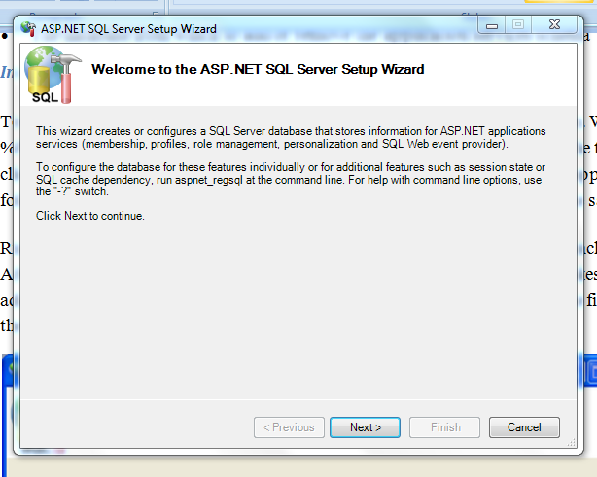

The second step in the wizard requests if you want to add or remove the application services. Because the author wanted to add the tables, views, and stored procedures required for the SqlMembershipProvider, the author chose the Configure SQL Server for application services option.

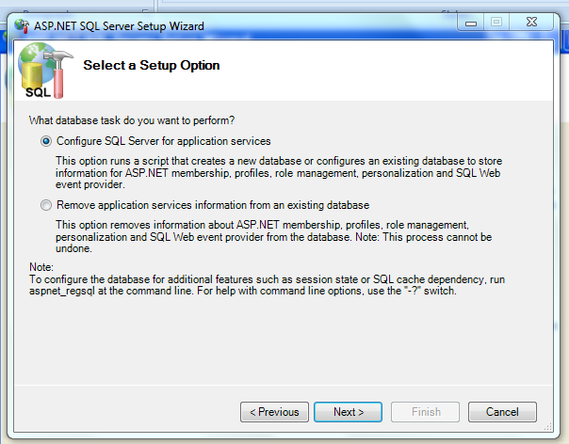

The third screen asks for the name of the server, authentication information and the name of the database which will be used.

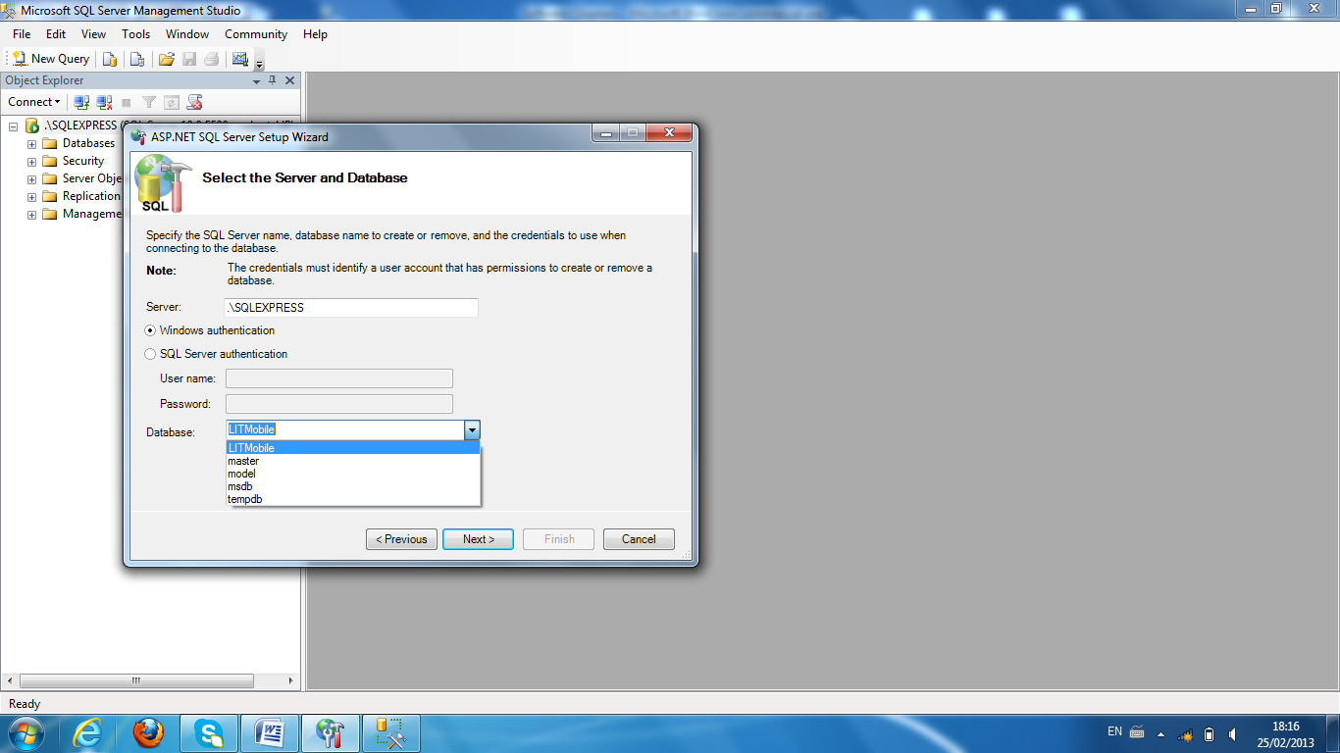

I then clicked next to install the application services and then finish to end the wizard. After the wizard finished, there was a variety of tables, views and stored procedures added in to the Gmit Mobile App database.

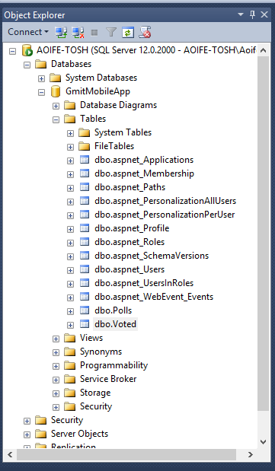

**How the User Account Information is Stored**

Account information for users is stored in the aspnet_Users and aspnet_Membership tables. The aspnet_Users table has the fields that store the necessary information about user’s accounts.

UserId is the primary key and of type uniqueidentifier. The user's credentials are made up of the UserName which is of type nvarchar and the password. The user's password is saved in the aspnet_Membership table. The ApplicationId connects the user account to a specific application in the aspnet_Applications table. There is a composite [unique constraint](http://msdn2.microsoft.com/en-us/library/ms191166.aspx) on the UserName and ApplicationId columns. This guarantees that in a given application each UserName is unique, however, it permits for the same UserName to be used in separate applicationsg

The aspnet_Membership table contains more user account information e.g. the user's password, email address, the last login date and time etc. There is a one-to-one relationship between entries in the aspnet_Users and aspnet_Membership tables. This correspondence is guaranteed by the UserId field in aspnet_Membership, which is used as the table's primary key.

**ASP.NET Configuration**

The Web Site Administration Tool allows developers to view and manage a web applications configuration via the graphical interface shown below.

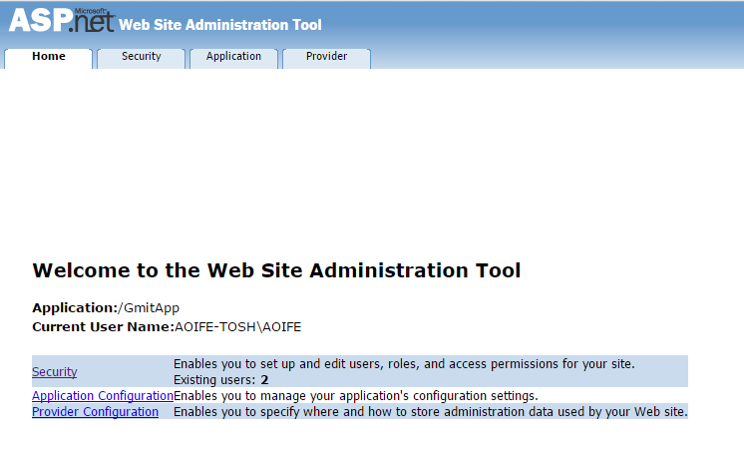

[**Web Application Configuration**](javascript:void(0))

The application configuration settings are located in the Web.config XML file. The Web Site Administration Tool allows you to change your app configuration instead of editing code in the Web.config file. Nearly all settings that are changed in the tool have an instant effect and are automatically added to the Web.config file.

[**Features**](javascript:void(0))

Security

Developers can use the Security tab to manage access rules to help protect certain resources within the application and to manage user accounts and roles.

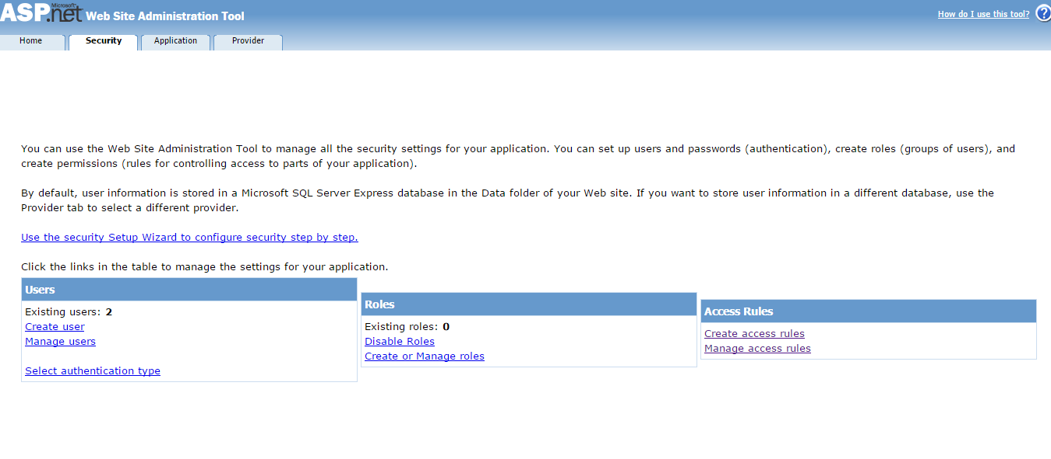

In the access rules tab, access certain users have on areas of the website can be controlled.

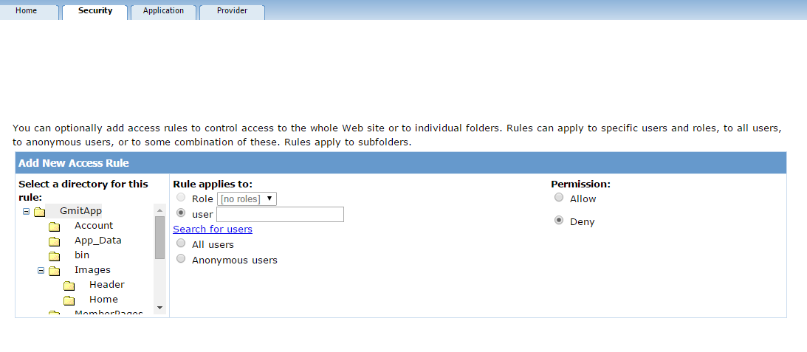

This allowed for restricting non registered users from accessing the poll and the maps area of the site.

**Application Tab**

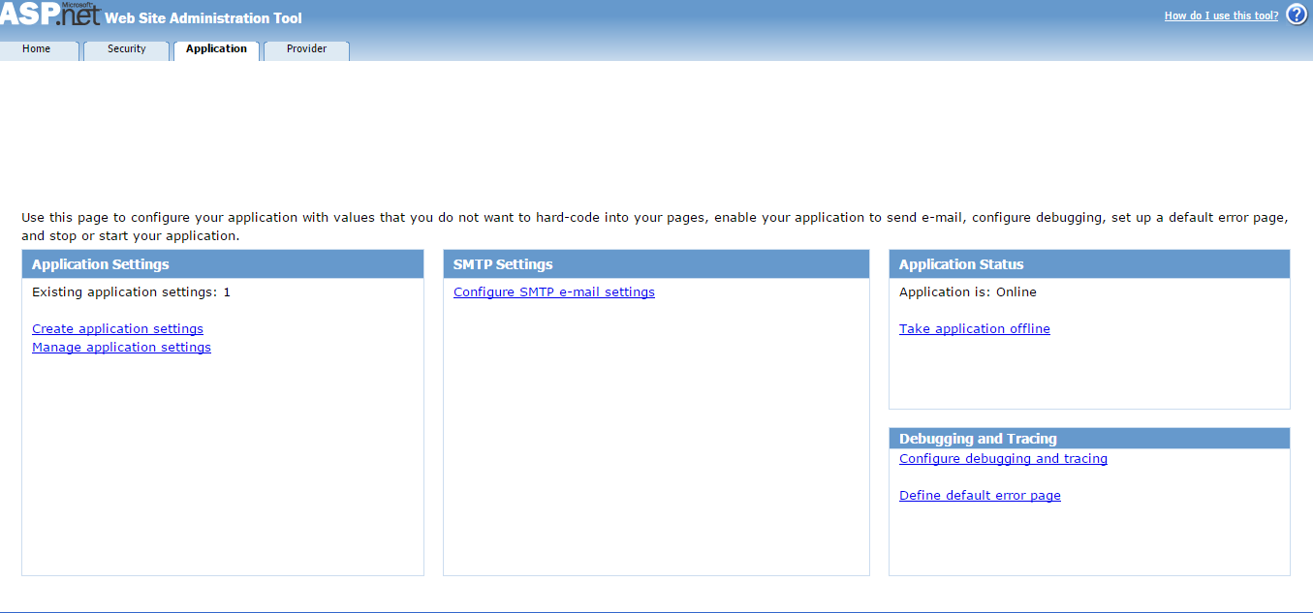

Developers can use the Application section to manage a number of the applications settings. These settings include:

* Application settings that are stored centrally and accessed in code from anywhere in the application.
* SMTP settings that configure how your application sends e-mails.
* Trace and debug settings.
* Offline/online settings that take the application offline (shut it down) so you can carry out maintenance or put a new database online.

**Development**

**Features**

*Login*

The default Visual Studio project templates for Web applications include prebuilt pages that provide developers with a base to work from. There prebuilt pages include: register, login and change password. However, there is a significant amount of development involved to change these base pages into a robust authentication system for a mobile web application.

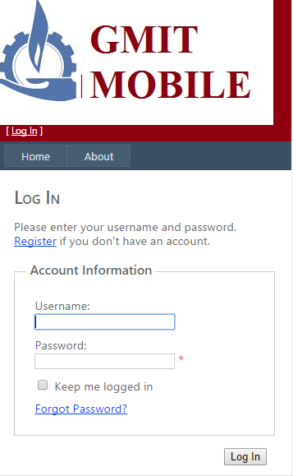

#### **Change Password**

The ChangePassword control uses the membership provider defined in the [MembershipProvider](http://msdn.microsoft.com/en-us/library/system.web.ui.webcontrols.changepassword.membershipprovider(v=vs.100).aspx) property to change the password stored in the membership provider data store for the application.

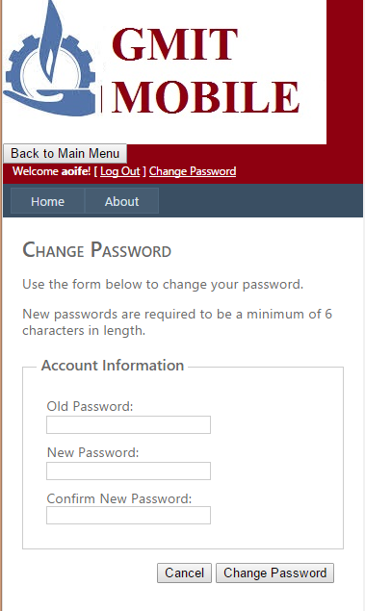

This control gives users the option to change their password. The user has to give the original password and then create the new password and confirm it. If the original password is correct, the user password is changed to the new password. Upon confirmation of the new password, the ChangePasswordSuccess page is displayed, where users can return to the home page.

**Recover Password**

The [PasswordRecovery](http://msdn.microsoft.com/en-us/library/system.web.ui.webcontrols.passwordrecovery(v=vs.100).aspx) control lets users retrieve their passwords by using the e-mail address that was given when the account was created. The [PasswordRecovery](http://msdn.microsoft.com/en-us/library/system.web.ui.webcontrols.passwordrecovery(v=vs.100).aspx) control sends an e-mail to the user which contains the user’s password. The [PasswordRecovery](http://msdn.microsoft.com/en-us/library/system.web.ui.webcontrols.passwordrecovery(v=vs.100).aspx) control needs your application to be able to forward e-mail messages to a Simple Mail Transfer Protocol (SMTP) server.

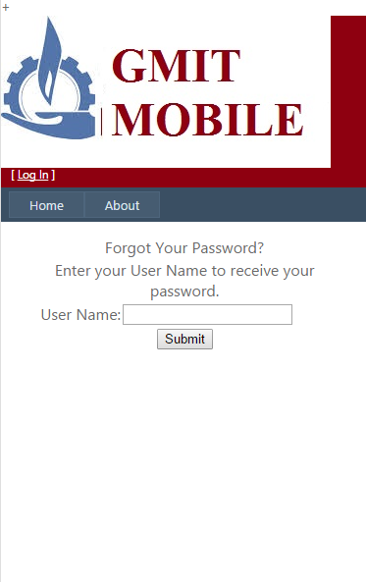

**Map**

Google Maps offers a flexible solution to integrate maps to offer directions, location information, and much more functionality provided by the Google Maps API into your mobile web app. The author used the directions feature in the app to help students to find Galway Mayo Institute of Technology.

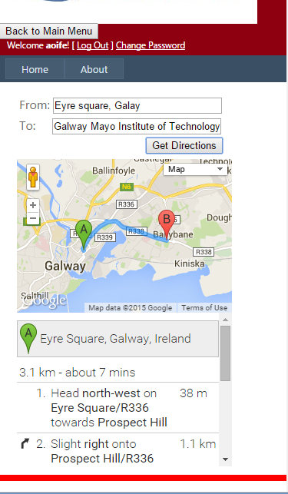

**Polls & Charts**

Users can answer intuitive polls which provide valuable feedback to GMIT. Users can also view the results of the polls via user-friendly, colourful pie charts.

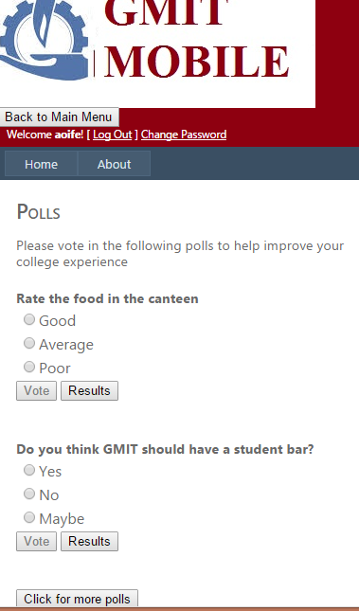

The vote button is disabled until the user selects an answer. Then the user is notified of their selection via a label. Users can only vote once on a poll. When a user selects an answer they are prompted with this validation message “You have already voted on this poll” and the vote button is disabled. However, users can view any of the charts at any time.

**Help**

Users can send any questions or problems they have with app to the application administrator email address. Validation messages appear if the user doesn’t fill out all the required fields which are: Name, email, subject and feedback. There is also a reset button available so users can clear the fields if they make any mistakes.

